1.Postman Setup

**Step : Setting up Postman**

* Open Postman and click on the sign up button to create a Postman Account.

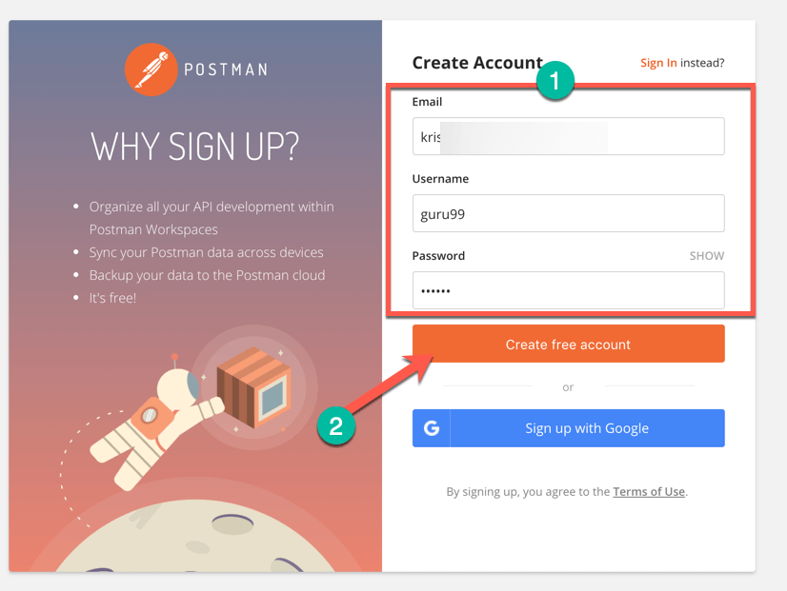

* NOTE: There are two ways to sign up for a Postman account. One is to create your own Postman account, and the other is to use a Google account. Though Postman allows users to use the tool without logging in, signing up ensures that your collection is saved and can be accessed for later use.
* Select the required workspace tools.
* Click on Save My Preferences.

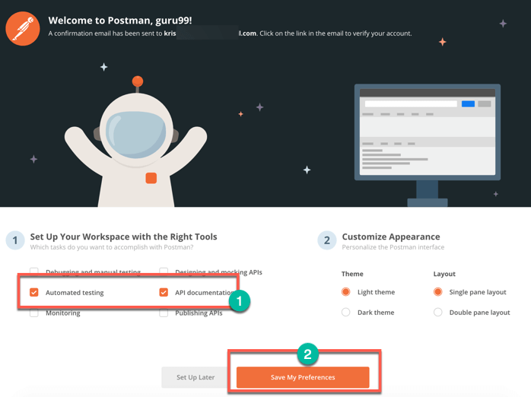

* You will see this Startup Screen below:

